**Press release – Radar**

**L-VEGA-RGB.wmfRadar is the better ultrasonic!**

**VEGA adds to its portfolio of level sensors with a new non-contact radar instrument series for standard measuring tasks and price-sensitive applications.**

A new era in radar level measurement began a few years ago when VEGAPULS sensors based on 80 GHz technology were introduced. Thanks to the more precise focusing of the radar beam, the sensor virtually eliminates any unwanted or interfering reflections – the level measurement therefore becomes much easier and more reliable. Many difficult measuring tasks for ultrasonic sensors are now becoming standard practice with radar technology.

VEGA has now added a new compact 80 GHz instrument series to its portfolio of radar sensors. It is especially suitable for price-sensitive applications, such as those found in the water/wastewater industry or in auxiliary process loops in process automation. VEGA designed a new radar microchip especially for this purpose, which is characterized by its extremely small size, fast start up time and low energy consumption. The end result is a particularly compact and versatile radar sensor.

**Robust, unaffected and weatherproof**

The new VEGAPULS instruments are ideal for both liquids and bulk solids. They are available both as compact version with cable connection housing and as a standard version with a fixed IP68 cable connection. The radar sensors maintain steady, accurate measurements without effect or loss of echo from external influences such as solar gain, air temperature fluctuations, weather conditions vapours, buildup or condensation. Users can choose from 4 ... 20 mA, HART, SDI-12 or Modbus as the direct output signal, ATEX versions are also available.

The VEGAPULS instrument series are compact devices, but they are complemented by the optional VEGAMET controllers. These feature a large graphic display that can be used to visualize all measured values. They have also been particularly designed to meet the special requirements of the water/wastewater industry. VEGAMET controllers allow simple implementation of pump control, flow measurement in open channels and overfill protection according to WHG. These are designed for operation in outdoor environments and, are supplied in a weather-resistant housing.

**Simple setup thanks to wireless operation**

Both the sensors and the controllers can be operated easily via Bluetooth with a smartphone or tablet. This makes setup, display and diagnostics considerably easier, especially in harsh environments or in hazardous areas.

The new VEGAPULS radar instrument series offers many advantages over current ultrasonic level measurement technologies. Thanks to their better all-conditions reliability, ruggedness, simple operation and, last but not least, low price it’s the obvious choice for the modern water industry applications.

Characters: 2,815

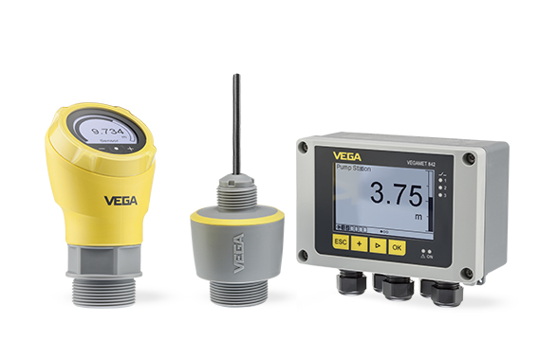

((Group-VEGAMET-VEGAPULS-09-300dpi-cmyk.tif))

The new VEGAPULS instrument series is available both as compact version with cable connection housing (left in the photo) and as standard version with fixed cable connection (IP68). The new series is complemented by the VEGAMET controller (right in the photo), which can also be used to visualize all measured values.

More information available at www.vega.com/vegapuls.